This week’s issue sponsored by the Home for Crazy Cat Ladies, Inc.

CLUES MEWS

Monday, November 7, 2011

Newman Headed For Newgate
THE

Pooch Park Prevails
Yes, we know that Newgate prison closed over 100 years ago, and that it is in England, but this miscreant is headed for the clink, the slammer, solitary confinement, water and dog chow.
Newman, whose last name is recorded only on district court documents, was convicted last Thursday of mayhem, the extent of which included June-hem, July-hem, etc. etc.
The charges included, but were not limited to shredding of toilet paper, kick boxing floor mats, and the coup de cat grass: slicing and dicing the paper towels. One horrified witness of the destruction, who rushed for their camera to record the attack, was too speechless to testify and simply handed over

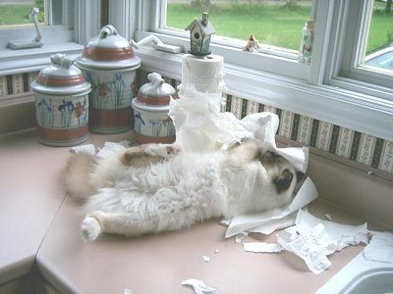

the evidence, to wit, the photo we print herein.
Newman’s attorneys, Clay Litter and Kahrdbored Box of Litter, Box, Attorneys at LawL, argued that Newman suffers from a rare condition known as “franticus feeticus”, which causes uncontrollable kicking in moments of great mental duress. Said condition comes on him without warning, and prevents him from enjoying the normal physical pursuits of a healthy cat such as jumping to high places.
The defense were a whisker short of (cont’d on p.2)
cont’d on p.2
conattack produced a subsequent photo taken the same day, of Newman on top of the kitchen cabinets, and no ladder in sight.

In libris graecis Maow C. Dung, chairman of almost every committee in town, failed in his bid on behalf of the Keep Our Sneakers Poop-Free committee to prevent the (cont’d on p.2) openicon et facilisis vituperatoribus. Mei eu ubique altera senserit.
Ea pro natum invidunt repudiandae, his et facilisis vituperatoribus. Mei eu ubique altera senserit, consul eripuit accusata has ne. Ea pro natum invidunt repudiandae, his et facilisis vituperatoribus. Sed ut nunc adipiscing leo porttitor pharetra. Nam dictum. Mauris eu eros. Aenean vulputate dolor quis felis. Etiam accumsan adipiscing massa. Nunc pharetra tortor a odio. Nullam molestie justo. Maecenas eget nunc. Nunc pellentesque aliquam magna. Suspendisse ultrices sodales orci. Vestibulum dolor dui, viverra sit amet, venenatis eu, volutpat vitae, massa. Aliquam at est.

Int’l News Briefs

At an open air mass in Rome this week, His Holiness blessed the animals. As the mass drew to a close, a handsome tabby visitor from Tonga, threw down his crutches and walked. However, as it turned out the visitor had been
(cont’d on p.2)
D po

Please spay and neuter your pets. The staff of the Clues Mews are all of the non-productive ilk. Some of them in more ways than one. Letters and questions to the Mews may be sent to cluesmews@mail.com. Please put topic in the subject line, e.g. letter to the editor, advice request, classified ad, request for a date with the publisher, news tip, media inquiries, gifts or general expressions of affection, photos, etc.
YOUR TITLE HERE

Fart in a can $.99. Guaranteed rank. Blame the dog anywhere, anytime

Advice
But it goes from udderly ridiculous to the totally insane when they start stuffing us in whatever strikes their demented fancy.
And if the costumes weren’t bad enough, they are now painting cats with everything from bikinis to Charlie Chaplin’s face on your nether regions. It has got to stop I tell you, and now!
Get out of that pumpkin and take back your dignity. Find their private stash of gorgonzola, eat it and woof your cookies in
their shoes. Unroll that
Editorial
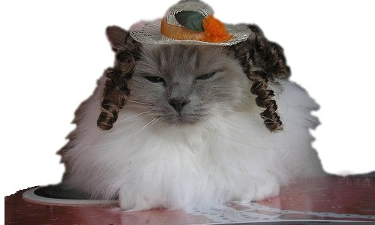

Now that the torture of Halloween is over for another year, we need to talk. I want you to look at this picture. I mean, really look at it. The phrases “dying of boredom” and “embarrassed beyond words” are the first things that come to mind. I mean really,
toilet paper in every room of the house then wind it around those priceless Royal Doulton figurines. Kick bonebreath out of the way, rip open the dog door, and stick your head out then yell “I’m mad as hell and I’m not going to take it anymore!”
Do it now, before it’s too late. Christmas is only a month away and you know what that means. Among other humiliations there’ll be another sweater from Aunt Millie. And reindeer antlers.
Can you stand it? I can’t.

when was the last time you wanted to be dressed in a foam hot dog bun so they can tell people you’re a badly bread example of a cat. And the tequila lime helmet? Not going to happen here unless they’ve got a pre-paid funeral plan.
There is something impossibly…scary about humans that have to dress us up to satisfy their inner idiot. It’s bad enough that they waddle around dressed as a cow with teats waving left and right.

Letters to the Editor

I think it’s disgraceful that our town council spends all that money on a dog park. Seriously, why don’t they just park them at those meters on Main Street? Tie their leashes to the post and come back every hour to put a quarter in. – Septimus Octavius

Frankly, I like the dog park. It was most considerate of the designer to include all those lovely clusters of bushes. I find the little doggies simply delicious. I mean delightful. – S. Nake

Has anyone found a large python? It escaped our house next to the dog park. – J. Smith

Letters may be edited for content, and/or snarkiness

Newman Headed… cont’d
Int’l Briefs…
cont’d
Pooch park....
cont’d
opening of the new dog park between Darcy and Division Streets. The flash mob of dog owners dressed in costumes ranging from “weiner” dogs to poodles, complete with matching hair-dos is suspected of having swung the vote on town council which passed the motion with only two dissenting votes. Those belonged to the cats of two councillors
and were not
considered valid.
Mayor Sy M. Hees declared the park open by cutting through a leash with large hedge clippers left there by a parks department worker. Unforunately the leash was not the ceremonial one, but was attached to a large Irish wolfhound which pursued His Honor’s Shih Tzu through the flower beds. She was eventually captured amongst the calendulas.

the visitor had been holding the crutches of someone next to him, who then needed help leaving the square.
The prize British Shorthair champion cat who escaped from the International Cat Show venue in Essex, England was later found on the grounds of Buckingham Palace. When asked where he’d been, he simply stared haughtily and replied ”To London, to see the queen.”

convincing the judge
even with expert veterinary evidence, when the witness to the attack produced a subsequent photo taken the same day, of Newman on top of the kitchen cabinets, and no ladder in sight.
His honor, Russ N. Blue set sentencing for next week in order to allow the defense to reprint their notes, which Newman had shredded during the recess.

Fake hairballs. Just add water for instant slimy, mess. Two for $5.00
ARTS & ENTERTAINMENT
Advice
down and run. Problem solved.
Dear PH: Staring at the can opener does not make it work. What am I doing wrong? – Signed: I.M.Hungry
Dear IMH: Stare at the human instead. Their capacity for guilt trips is bottomless.
Dear PH: What is the meaning of life? – Signed: René Descartes
Dear RD: Stop watching PBS and get a life. Go chase a bird or something.
Sports Shorts

Charges are pending from the skirmish that occurred during the semi-finals of last weekend’s Roller Poopy tournament.
Da Moose, who has been the reigning regional champion the last three years running, made a splendid dive in the closing seconds of her match, only to have the puck escape her paw, ricochet off the glass, and become lodged in the left nostril of her
opponent’s coach. The subsequent hair-pulling and shrieking match was apparently more about whether the puck could be played “in situ” so to speak or whether the shot would have to be taken over.
Tickets are now available at the box office for December’s Demolition Derby. Rev up your Rhumba’s and enter now. Special book signing and autograph session with Dale Furnheart.


Dear PH: My people got a dog. I don’t like the dog. What can I do?- Signed: dogbreathstinks
Dear dbs: Drop a dog cookie on the floor under a shelf with priceless breakable things. Then knock one

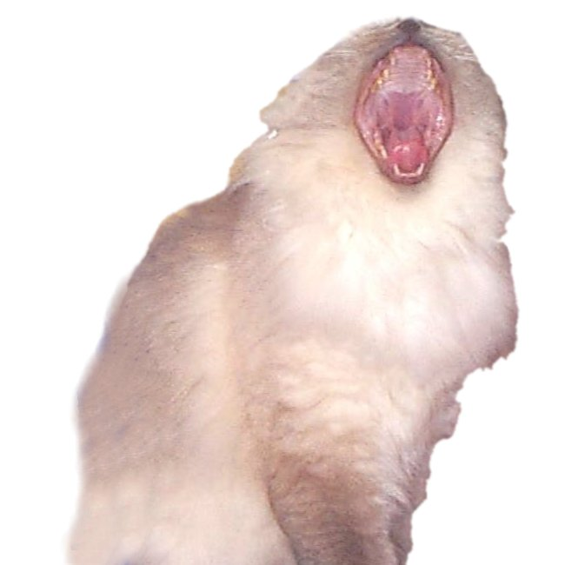

The world-famous diva known only as the Vagnerian Phat Lady, gave a brief performance on her farewell tour at the Bird’s Nest theatre on the weekend. While presenting a selection from the body of works known as “Carmina Purrana”, the diva stepped to the edge of the stage and instead of a swan song, performed a swan dive into the orchestra pit.
For the first time in theatre history, the manager was forced to ask if there was a veterinarian in the house. Diva Phat Lady is taking a break from the tour, and the conductor’s scratches are expected to heal in good time.
pellentesque aliquam magna.

Public Service Announcements
Our readers’
photos
PAWS UP
Classified
Ads

A big paws up to every fireman who has ever climbed a ladder to rescue a cat, or pulled one from a burning building and given it oxygen. You are a man among men, and so are the firewomen.
Kudos to the demented minds behind LOL Cats. We need more feline humour. Especially the kind that disses dogs and makes the cat look good. Of course, it’s hard to make us look bad.

The Procrastinator’s Anonymous meeting at the community center has been put off until tomorrow, same time and room.

The Ladies Auxiliary is still seeking recipes for their annual fund-raising cookbook, so if you have a new way to serve minced mice, please submit your recipe by Mon. Nov.14. No canine casserole recipes will be accepted.



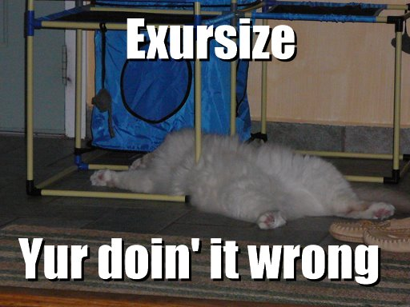

Wanted: Information on the whereabouts of a sleek, tiger striped male cat, last seen 63 days ago. Apply to orange female cat with six striped kittens at 26 Lin St.
Lost: 1 catnip mouse. Last seen swirling in toilet bowl. Reward. Call Fluffy at 555-3619
For sale: human 6 weeks old. Noisy, smells odd. Reason for sale: interrupts my nap. Email bcat@nightmare.commm

